WOXSEN UNIVERSITY
School of Technology

Design and Implementation of a Database Management System for Hostel Accommodation and Student Services



DATABASE MANAGEMENT SYSTEMS
Course Project Report
B.Tech — Artificial Intelligence and Machine Learning
Second Year | Academic Year 2026–2027
Group member | Roll number
Sruthika | 25WU0102312
Thrishith | 25WU0102291
Sahasraa | 25WU0101117
Faculty: Dr.Kiranmayee Advala
Section: AIML Wolves
Date: 6 October 2026

2. Abstract
Hostel administration involves several connected tasks, yet the information needed for them is often recorded separately. Our project brings student profiles, accommodation, fees, complaints, leave requests and notices into one relational system. We chose this problem because it shows how database design can support everyday decisions, such as finding a vacant bed or checking whether a student’s leave has been approved.
The application uses Python and Flask with HTML, CSS and JavaScript. Its nine-table design supports MySQL 8.0, with SQLite available as a local fallback. Students have a personal dashboard, while wardens and administrators use a shared management portal. The report connects the presentation to the actual SQL definitions, backend routes and supplied screenshots. It also evaluates the limits of the current prototype, particularly consistency between stored occupancy and allocations and compatibility between the two database engines.
The project demonstrates the practical value of keys, relationships, joins and aggregates. CRUD was studied as a concept and included in the presentation, but has not been integrated into the application. The current work is a course prototype. Keywords: hostel management, MySQL, Flask, relational design, student services.

3. Introduction and Problem Statement
A hostel office needs to know more than where a student lives. It also needs to track room transfers, fee balances, maintenance issues and permissions to leave campus. If each activity is managed in a separate register or chat, the office may have several versions of the same information. Students, in turn, may be unable to see whether their request has been received or acted upon.
Our problem statement is therefore to design a database-backed application that connects accommodation and student services through a common student record. The system should support both the resident’s view of their own information and the warden’s view of the hostel as a whole. This gives the project a clear purpose: improving access to records while preserving the relationships between them.
The presentation identifies six weaknesses in the manual approach: scattered student records, unclear bed availability, poorly tracked complaints, separate fee ledgers, missing outpass history and incomplete administrative visibility. These are the project’s motivating assumptions; no formal survey measuring their frequency was supplied.
The course specification requires a relational design, normalization up to 3NF, at least five records per table, joins and aggregates, and a connected UI demonstrating insert, delete and view operations. The report follows its seventeen-section order.

4. Objectives and Scope
Objective | How the system addresses it
Centralise student records | Student profiles are linked to login accounts and service records.
Manage rooms and beds | Room and allocation records track the accommodation assigned to each student.
Track fees and dues | Fee records distinguish billed amounts, collections and balances.
Follow up complaints | Tickets carry categories, priorities, status and resolution notes.
Handle leave requests | Applications store dates, reasons, decisions and warden remarks.
Publish notices | Announcements are categorised, timestamped and optionally pinned.
The application defines student, warden and administrator roles. A student can view room details, fees and notices, submit complaints and leave requests, and update parts of their profile. The management portal includes student records, rooms, allocations, fee management, complaints, leave approvals, notices, reports and a Database Hub.
One distinction matters when interpreting the presentation: it describes separate role responsibilities, but the current admin_required decorator permits both administrators and wardens to access the same management routes. The implemented separation is therefore between students and management, with limited distinction between the two management roles.
The scope is a seeded academic prototype. Example residents, hostel staff and notices are demonstration data rather than verified institutional records. The fee screen simulates recording payments; the reviewed code does not establish integration with a banking or payment provider.

5. Software and Hardware Requirements
Layer | Confirmed implementation
Frontend | HTML templates, CSS, JavaScript and Jinja rendering.
Backend | Python with Flask; Flask and Werkzeug ≥2.3 are declared dependencies.
Database access | PyMySQL ≥1.1 for MySQL; Python sqlite3 for fallback.
MySQL schema | MySQL 8.0+, InnoDB, utf8mb4, SQL views and a generated fee balance.
Other dependencies | cryptography ≥41 and python-dotenv ≥1.0.
Database tool | MySQL Workbench, shown in supplied result screenshots.
API entry point | api/app.py and api/index.py import and export the Flask application as a WSGI handler.
Hardware | A laptop/desktop running Python, a browser and the database. Actual CPU/RAM specifications were not provided.
In auto mode, db.py attempts a configured MySQL connection and falls back to SQLite if the connection cannot be established. Both supplied dashboard screenshots explicitly display “DB: SQLITE”. The MySQL Workbench screenshots are separate evidence of the MySQL data; they do not show the dashboard using that same connection.

6. ER Diagram
Figure 1 represents the foreign keys in the repository’s MySQL schema. Notice is a standalone table: posted_by stores text, so it does not form a foreign-key relationship to Users.
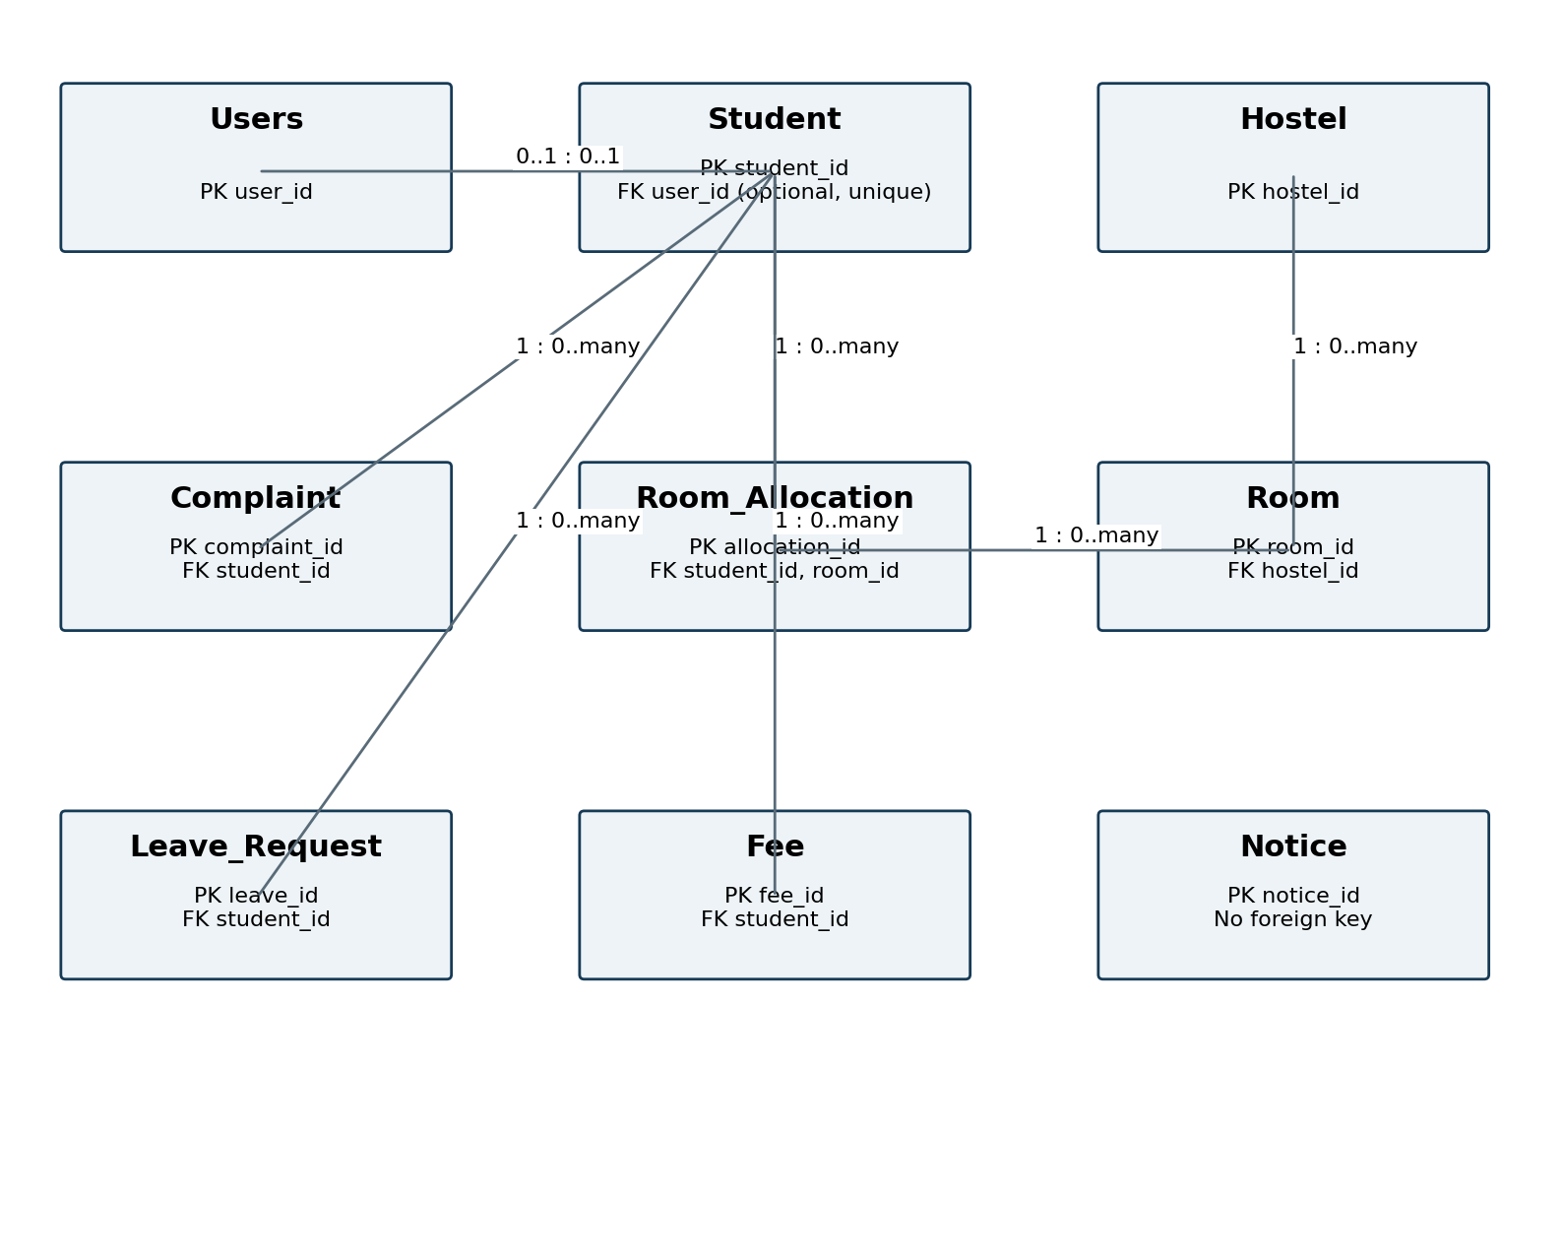
Figure 1. ER diagram based on the repository schema.
Relationship | Cardinality / participation
Users–Student | Student.user_id is nullable and unique: each Student has zero or one User; each User has zero or one Student profile.
Hostel–Room | Every Room requires one Hostel; a Hostel can have zero or many rooms.
Student–Room_Allocation | Each allocation requires one student; a student can have many historical allocations.
Room–Room_Allocation | Each allocation requires one room; a room can have many historical allocations.
Student–Fee / Complaint / Leave_Request | Every service row requires one student; each student may have zero or many service records.
Notice | Independent entity; textual posted_by does not enforce a linked user.
All declared foreign keys use ON DELETE CASCADE. Deleting a parent can therefore delete dependent records. This is convenient for demo cleanup, but a real hostel would need to decide which records must be retained before using the same deletion policy.

7. Relational Schema and Normalization
Users (user_id, username, password_hash, role, created_at)
Hostel (hostel_id, hostel_name, hostel_type, location, warden_name, contact_phone, total_rooms)
Student (student_id, user_id, roll_number, name, email, phone, course, year, gender, emergency_contact, guardian_name, address, created_at)
Room (room_id, hostel_id, room_number, room_type, capacity, occupied, fee_per_semester, status)
Room_Allocation (allocation_id, student_id, room_id, allocation_date, status, remarks, created_at)
Fee (fee_id, student_id, academic_term, amount, amount_paid, due_amount, payment_date, status, transaction_ref, remarks, created_at)
Complaint (complaint_id, student_id, complaint_type, title, description, priority, complaint_date, status, resolution_notes, resolved_at)
Leave_Request (leave_id, student_id, leave_type, start_date, end_date, reason, emergency_contact, status, admin_remarks, applied_at)
Notice (notice_id, title, category, description, date_posted, posted_by, is_pinned)
The schema divides the hostel into nine entities rather than placing every detail in one student table. This prevents a complaint or a second leave application from requiring extra repeating columns. It also allows a room or notice to exist independently of a particular student.

7.1 First Normal Form
The tables have primary keys and single-valued fields. Separate rows represent repeated activities, such as complaints and leave applications. A student can therefore have several requests without placing a list of requests inside their profile.

7.2 Second Normal Form
The declared primary keys are single-column identifiers, so no non-key attribute depends on only part of those primary keys. Room also has a composite unique key on hostel_id and room_number: room numbers are unique within a hostel, rather than necessarily across the campus.

7.3 Third Normal Form and deliberate redundancy
The main decomposition keeps student, room and hostel descriptions in their own relations. Allocation rows reference Student and Room instead of repeating names and hostel details. However, the implemented schema retains several values derived from other information, so it would be inaccurate to describe every stored relation as strictly 3NF without qualification.
Stored value | Dependency / evaluation
Fee.due_amount | amount − amount_paid; MySQL generates it automatically. It remains a derived attribute rather than an independent fact.
Room.occupied | Should equal the number of active allocations. It is stored and updated by backend logic.
Room.status | Partly reflects occupancy, but also includes Under Maintenance; it combines availability and operational state.
Hostel.total_rooms | A stored count alongside Room records; seeded values do not equal the nine-room demo inventory.
Fee.status | Paid/Partial/Pending reflects amounts; consistency depends on updates.
Our interpretation is that the system applies normalization to its core entities, then retains some summaries for the dashboard. This is a practical trade-off only if the summaries remain consistent. The current seed exposes that risk: A-104 is marked occupied by one resident even though no active allocation points to it. A stricter design would calculate occupancy and room counts, and keep a separate maintenance state.

8. Data Dictionary
The definitions below are taken from backend/database.sql. PK fields are auto-incrementing integers. All tables use InnoDB and utf8mb4; every declared foreign key cascades on parent deletion.

Users
Field | MySQL type | Constraints / default
user_id | INT | AUTO_INCREMENT PRIMARY KEY
username | VARCHAR(60) | NOT NULL UNIQUE
password_hash | VARCHAR(255) | NOT NULL
role | ENUM('admin', 'warden', 'student') | NOT NULL DEFAULT 'student'
created_at | TIMESTAMP | DEFAULT CURRENT_TIMESTAMP

Hostel
Field | MySQL type | Constraints / default
hostel_id | INT | AUTO_INCREMENT PRIMARY KEY
hostel_name | VARCHAR(100) | NOT NULL UNIQUE
hostel_type | ENUM('Girls', 'Boys', 'Co-Ed') | NOT NULL DEFAULT 'Girls'
location | VARCHAR(150) | DEFAULT 'Woxsen University Campus, Hyderabad'
warden_name | VARCHAR(100) | DEFAULT 'Dr. Sunita Rao'
contact_phone | VARCHAR(20) | DEFAULT '+91 9845012345'
total_rooms | INT | DEFAULT 0

Student
Field | MySQL type | Constraints / default
student_id | INT | AUTO_INCREMENT PRIMARY KEY
user_id | INT | UNIQUE
roll_number | VARCHAR(30) | NOT NULL UNIQUE
name | VARCHAR(100) | NOT NULL
email | VARCHAR(100) | NOT NULL UNIQUE
phone | VARCHAR(20) | NOT NULL
course | VARCHAR(60) | NOT NULL
year | VARCHAR(20) | NOT NULL
gender | ENUM('Female', 'Male', 'Other') | NOT NULL DEFAULT 'Female'
emergency_contact | VARCHAR(20) | Nullable; no additional constraint
guardian_name | VARCHAR(100) | Nullable; no additional constraint
address | TEXT | Nullable; no additional constraint
created_at | TIMESTAMP | DEFAULT CURRENT_TIMESTAMP
FOREIGN KEY (user_id) REFERENCES Users(user_id) ON DELETE CASCADE

Room
Field | MySQL type | Constraints / default
room_id | INT | AUTO_INCREMENT PRIMARY KEY
hostel_id | INT | NOT NULL
room_number | VARCHAR(20) | NOT NULL
room_type | ENUM('Single AC', 'Single Non-AC', 'Double AC', 'Double Non-AC', 'Triple Non-AC') | NOT NULL
capacity | INT | NOT NULL DEFAULT 2
occupied | INT | NOT NULL DEFAULT 0
fee_per_semester | DECIMAL(10, 2) | NOT NULL DEFAULT 35000.00
status | ENUM('Available', 'Full', 'Under Maintenance') | NOT NULL DEFAULT 'Available'
UNIQUE KEY unique_hostel_room (hostel_id, room_number)
FOREIGN KEY (hostel_id) REFERENCES Hostel(hostel_id) ON DELETE CASCADE

Room_Allocation
Field | MySQL type | Constraints / default
allocation_id | INT | AUTO_INCREMENT PRIMARY KEY
student_id | INT | NOT NULL
room_id | INT | NOT NULL
allocation_date | DATE | NOT NULL
status | ENUM('Active', 'Vacated', 'Transferred') | NOT NULL DEFAULT 'Active'
remarks | VARCHAR(255) | DEFAULT 'Allocated by Woxsen Warden'
created_at | TIMESTAMP | DEFAULT CURRENT_TIMESTAMP
FOREIGN KEY (student_id) REFERENCES Student(student_id) ON DELETE CASCADE
FOREIGN KEY (room_id) REFERENCES Room(room_id) ON DELETE CASCADE

Fee
Field | MySQL type | Constraints / default
fee_id | INT | AUTO_INCREMENT PRIMARY KEY
student_id | INT | NOT NULL
academic_term | VARCHAR(50) | NOT NULL DEFAULT 'Fall Semester 2026'
amount | DECIMAL(10, 2) | NOT NULL
amount_paid | DECIMAL(10, 2) | NOT NULL DEFAULT 0.00
due_amount | DECIMAL(10, 2) | GENERATED ALWAYS AS (amount - amount_paid) STORED
payment_date | DATE | Nullable; no additional constraint
status | ENUM('Paid', 'Pending', 'Partial') | NOT NULL DEFAULT 'Pending'
transaction_ref | VARCHAR(100) | Nullable; no additional constraint
remarks | VARCHAR(255) | Nullable; no additional constraint
created_at | TIMESTAMP | DEFAULT CURRENT_TIMESTAMP
FOREIGN KEY (student_id) REFERENCES Student(student_id) ON DELETE CASCADE

Complaint
Field | MySQL type | Constraints / default
complaint_id | INT | AUTO_INCREMENT PRIMARY KEY
student_id | INT | NOT NULL
complaint_type | ENUM('Water', 'Electricity', 'Fan/AC', 'Wi-Fi', 'Cleanliness', 'Maintenance', 'Other') | NOT NULL
title | VARCHAR(150) | NOT NULL
description | TEXT | NOT NULL
priority | ENUM('Low', 'Medium', 'High', 'Emergency') | NOT NULL DEFAULT 'Medium'
complaint_date | TIMESTAMP | DEFAULT CURRENT_TIMESTAMP
status | ENUM('Pending', 'In Progress', 'Resolved') | NOT NULL DEFAULT 'Pending'
resolution_notes | TEXT | Nullable; no additional constraint
resolved_at | TIMESTAMP | NULL
FOREIGN KEY (student_id) REFERENCES Student(student_id) ON DELETE CASCADE

Leave_Request
Field | MySQL type | Constraints / default
leave_id | INT | AUTO_INCREMENT PRIMARY KEY
student_id | INT | NOT NULL
leave_type | ENUM('Weekend Home', 'Medical', 'Academic/Event', 'Emergency', 'Other') | NOT NULL DEFAULT 'Weekend Home'
start_date | DATE | NOT NULL
end_date | DATE | NOT NULL
reason | TEXT | NOT NULL
emergency_contact | VARCHAR(20) | Nullable; no additional constraint
status | ENUM('Pending', 'Approved', 'Rejected') | NOT NULL DEFAULT 'Pending'
admin_remarks | VARCHAR(255) | Nullable; no additional constraint
applied_at | TIMESTAMP | DEFAULT CURRENT_TIMESTAMP
FOREIGN KEY (student_id) REFERENCES Student(student_id) ON DELETE CASCADE

Notice
Field | MySQL type | Constraints / default
notice_id | INT | AUTO_INCREMENT PRIMARY KEY
title | VARCHAR(150) | NOT NULL
category | ENUM('General', 'Maintenance', 'Fee Deadline', 'Events', 'Urgent') | NOT NULL DEFAULT 'General'
description | TEXT | NOT NULL
date_posted | TIMESTAMP | DEFAULT CURRENT_TIMESTAMP
posted_by | VARCHAR(100) | DEFAULT 'Woxsen Hostel Administration'
is_pinned | BOOLEAN | DEFAULT FALSE
The SQL script does not declare CHECK constraints for room capacity, occupancy, payment limits or leave date order. Some checks are implemented in routes; they should not be described as database constraints. SQLite uses TEXT for enums, REAL for money and an ordinary stored due_amount, whereas MySQL uses ENUM, DECIMAL and a generated balance.

9. SQL Commands Used (DDL, DML) with Sample Outputs

9.1 Database and table creation
CREATE DATABASE IF NOT EXISTS hostel_management;
USE hostel_management;

Two representative table definitions from the actual script are reproduced below; the full script in the repository defines all nine tables and two views.
CREATE TABLE Room_Allocation (
allocation_id INT AUTO_INCREMENT PRIMARY KEY,
student_id INT NOT NULL,
room_id INT NOT NULL,
allocation_date DATE NOT NULL,
status ENUM('Active', 'Vacated', 'Transferred') NOT NULL DEFAULT 'Active',
remarks VARCHAR(255) DEFAULT 'Allocated by Woxsen Warden',
created_at TIMESTAMP DEFAULT CURRENT_TIMESTAMP,
FOREIGN KEY (student_id) REFERENCES Student(student_id) ON DELETE CASCADE,
FOREIGN KEY (room_id) REFERENCES Room(room_id) ON DELETE CASCADE
) ENGINE=InnoDB DEFAULT CHARSET=utf8mb4;

CREATE TABLE Fee (
fee_id INT AUTO_INCREMENT PRIMARY KEY,
student_id INT NOT NULL,
academic_term VARCHAR(50) NOT NULL DEFAULT 'Fall Semester 2026',
amount DECIMAL(10, 2) NOT NULL,
amount_paid DECIMAL(10, 2) NOT NULL DEFAULT 0.00,
due_amount DECIMAL(10, 2) GENERATED ALWAYS AS (amount - amount_paid) STORED,
payment_date DATE,
status ENUM('Paid', 'Pending', 'Partial') NOT NULL DEFAULT 'Pending',
transaction_ref VARCHAR(100),
remarks VARCHAR(255),
created_at TIMESTAMP DEFAULT CURRENT_TIMESTAMP,
FOREIGN KEY (student_id) REFERENCES Student(student_id) ON DELETE CASCADE
) ENGINE=InnoDB DEFAULT CHARSET=utf8mb4;

The schema uses PRIMARY KEY, UNIQUE, NOT NULL, ENUM and FOREIGN KEY declarations. The generated due_amount column is calculated by MySQL, so normal INSERT and UPDATE statements should not supply a numeric value for that column.

9.2 Insertion
INSERT INTO Room_Allocation
(student_id, room_id, allocation_date, status, remarks)
VALUES (1, 1, '2026-08-01', 'Active',
'Allocated for Academic Year 2026-27');
INSERT INTO Fee
(student_id, academic_term, amount, amount_paid, status)
VALUES (1, 'Fall Semester 2026', 45000.00, 45000.00, 'Paid');

These statements reproduce rows from the seed script. They explain SQL insertion independently of the UI and are examples for a fresh seed, not instructions to reinsert duplicates into the existing database. The supplied Workbench log records six inserted students, six allocations, six fees, five complaints, four leave requests and four notices. Manual SQL execution is not evidence that CRUD has been integrated into the application.

9.3 Update and delete
UPDATE Complaint SET status = 'Resolved',
resolution_notes = 'Issue checked and resolved',
resolved_at = CURRENT_TIMESTAMP WHERE complaint_id = 1;
-- For a temporary test notice only:
DELETE FROM Notice WHERE notice_id = @test_notice_id;

A matching changed row gives an affected-row result; deleting an ID that does not exist affects zero rows. These UPDATE and DELETE statements illustrate CRUD at the SQL level. No screenshot of their execution was supplied. Although the repository contains relevant route code, the group confirms that CRUD has not been integrated into the project; the report therefore treats these routes as intended implementation rather than completed functionality.
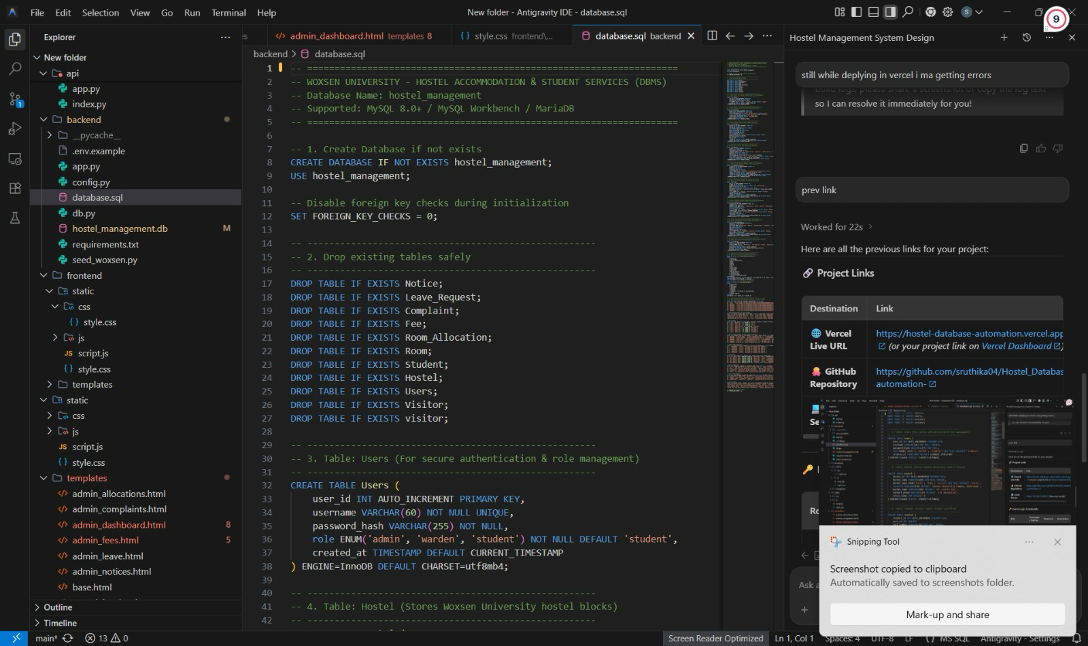
Figure 2. Supplied database initialization script and project structure.

10. Queries with Outputs
This section distinguishes supplied MySQL screenshots, outputs reproduced from the repository’s bundled SQLite database, and dashboard observations. The bundled database was opened read-only, preserving its contents. The snapshot contains the same fee totals as the earlier MySQL fee image, but differs from the later dashboard.

10.1 Student records
SELECT student_id, roll_number, name FROM Student ORDER BY student_id;

student_id | roll_number | name
1 | WU202601 | Sruthika Reddy
2 | WU202602 | Ananya Deshmukh
3 | WU202603 | Kavya Sharma
4 | WU202604 | Sneha Patel
5 | WU202605 | Riya Sen
6 | WU202606 | Pooja Verma
Output reproduced from the bundled SQLite snapshot; query syntax is also compatible with MySQL.
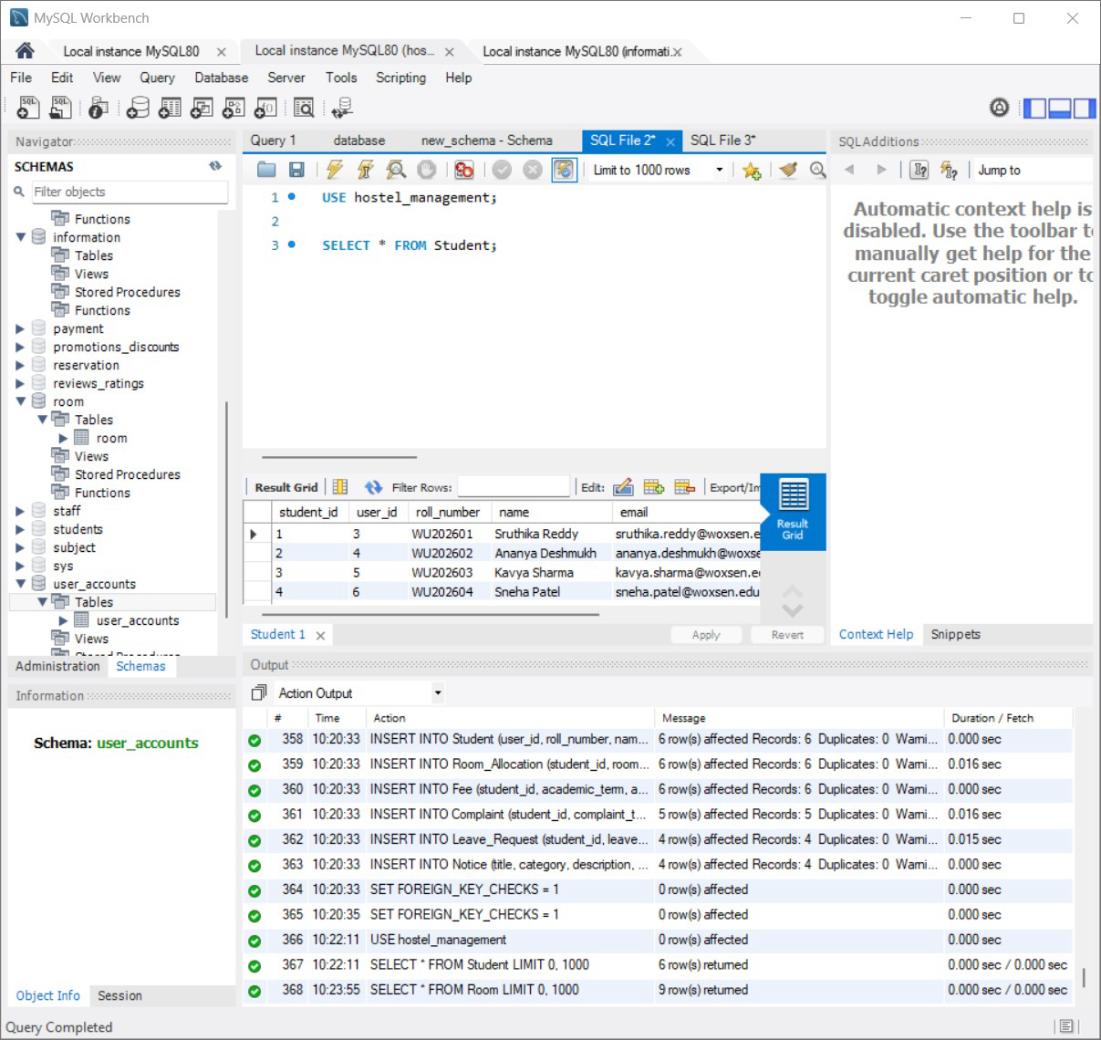
Figure 3. Original MySQL student query result.

10.2 Room inventory
SELECT room_number, capacity, occupied, capacity - occupied AS available_beds FROM Room ORDER BY room_id;

room_number | capacity | occupied | available_beds
A-101 | 2 | 2 | 0
A-102 | 2 | 2 | 0
A-103 | 1 | 1 | 0
A-104 | 2 | 1 | 1
B-201 | 2 | 1 | 1
B-202 | 1 | 0 | 1
C-101 | 2 | 0 | 2
C-102 | 1 | 0 | 1
D-101 | 2 | 0 | 2
Output reproduced from the bundled SQLite snapshot; query syntax is also compatible with MySQL.
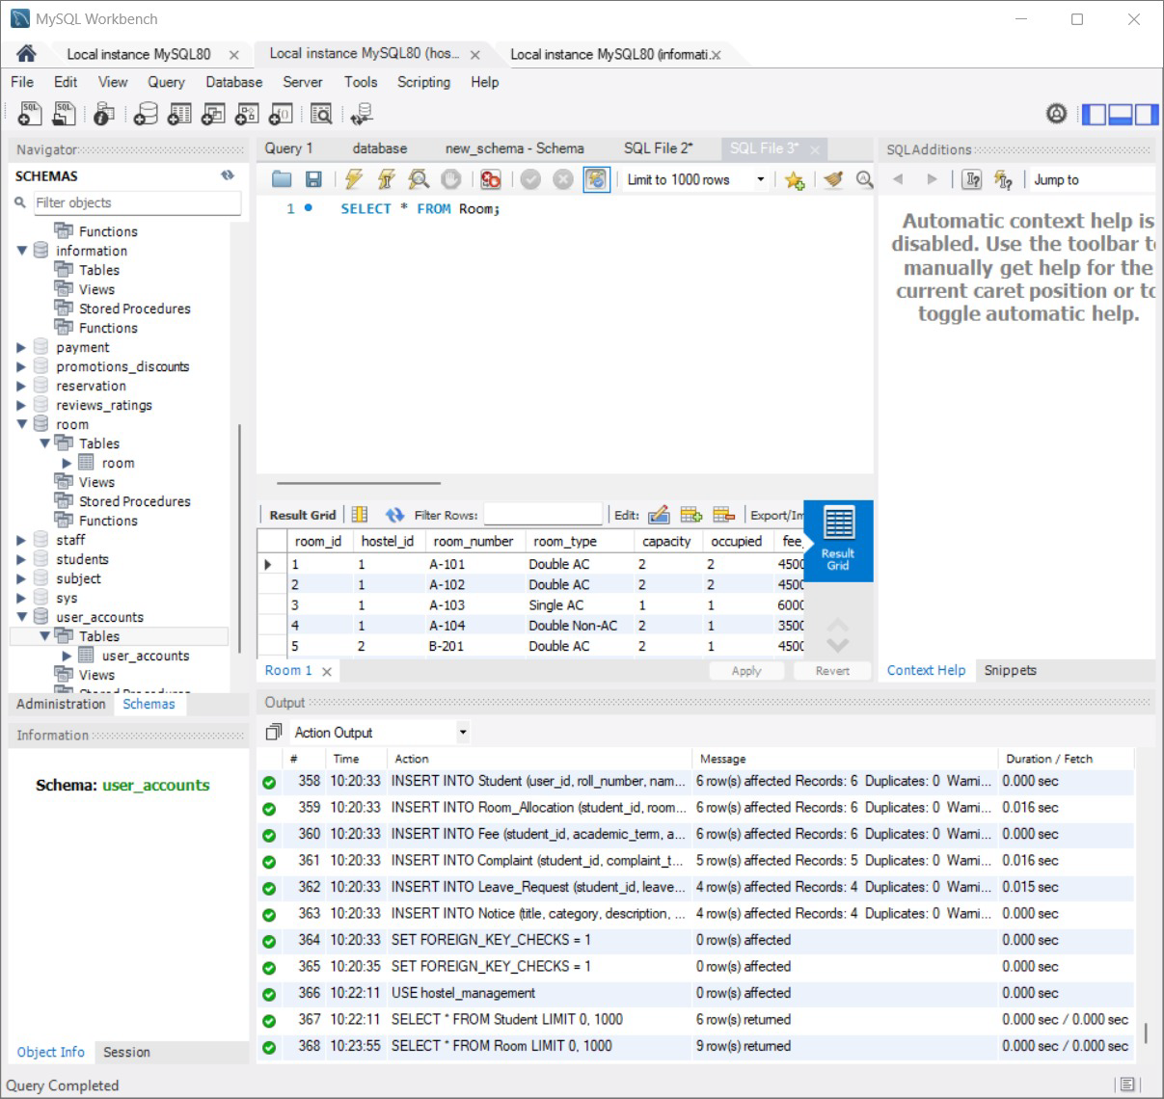
Figure 4. Supplied Room query. Although described as Room Allocation in the attachment list, the displayed statement selects Room.

10.3 Allocation join
SELECT s.roll_number, s.name, r.room_number, ra.status
FROM Room_Allocation ra
JOIN Student s ON s.student_id = ra.student_id
JOIN Room r ON r.room_id = ra.room_id
WHERE ra.status = 'Active' ORDER BY s.student_id;

roll_number | name | room_number | status
WU202601 | Sruthika Reddy | A-101 | Active
WU202602 | Ananya Deshmukh | A-101 | Active
WU202603 | Kavya Sharma | A-102 | Active
WU202604 | Sneha Patel | A-102 | Active
WU202605 | Riya Sen | A-103 | Active
WU202606 | Pooja Verma | B-201 | Active
Output reproduced from the bundled SQLite snapshot; query syntax is also compatible with MySQL.

10.4 Complaint summary
SELECT complaint_type, status FROM Complaint ORDER BY complaint_id;

complaint_type | status
Wi-Fi | In Progress
Water | Resolved
Cleanliness | Pending
Electricity | In Progress
Fan/AC | Pending
Output reproduced from the bundled SQLite snapshot; query syntax is also compatible with MySQL.
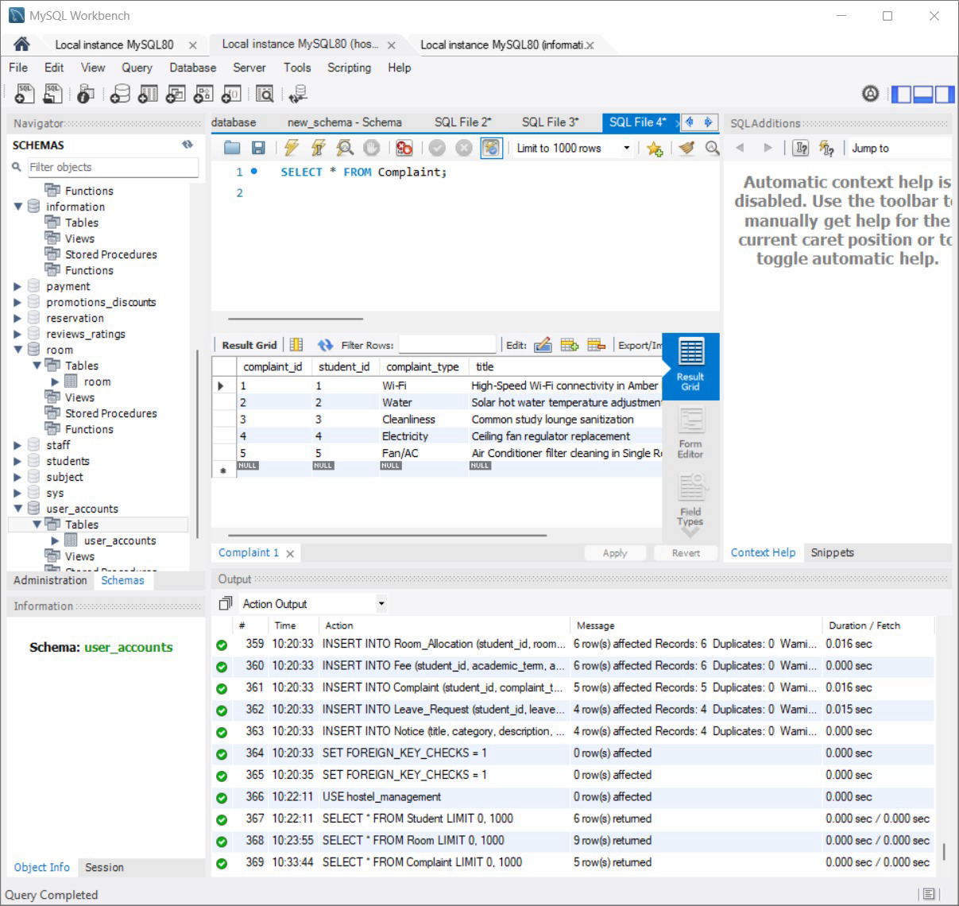
Figure 5. MySQL complaint query: five stored complaints.

10.5 Leave requests
SELECT leave_id, leave_type, start_date, end_date, status FROM Leave_Request ORDER BY leave_id;

leave_id | leave_type | start_date | end_date | status
1 | Weekend Home | 2026-10-10 | 2026-10-13 | Approved
2 | Medical | 2026-10-06 | 2026-10-08 | Approved
3 | Academic/Event | 2026-10-15 | 2026-10-18 | Pending
4 | Weekend Home | 2026-10-20 | 2026-10-23 | Pending
Output reproduced from the bundled SQLite snapshot; query syntax is also compatible with MySQL.
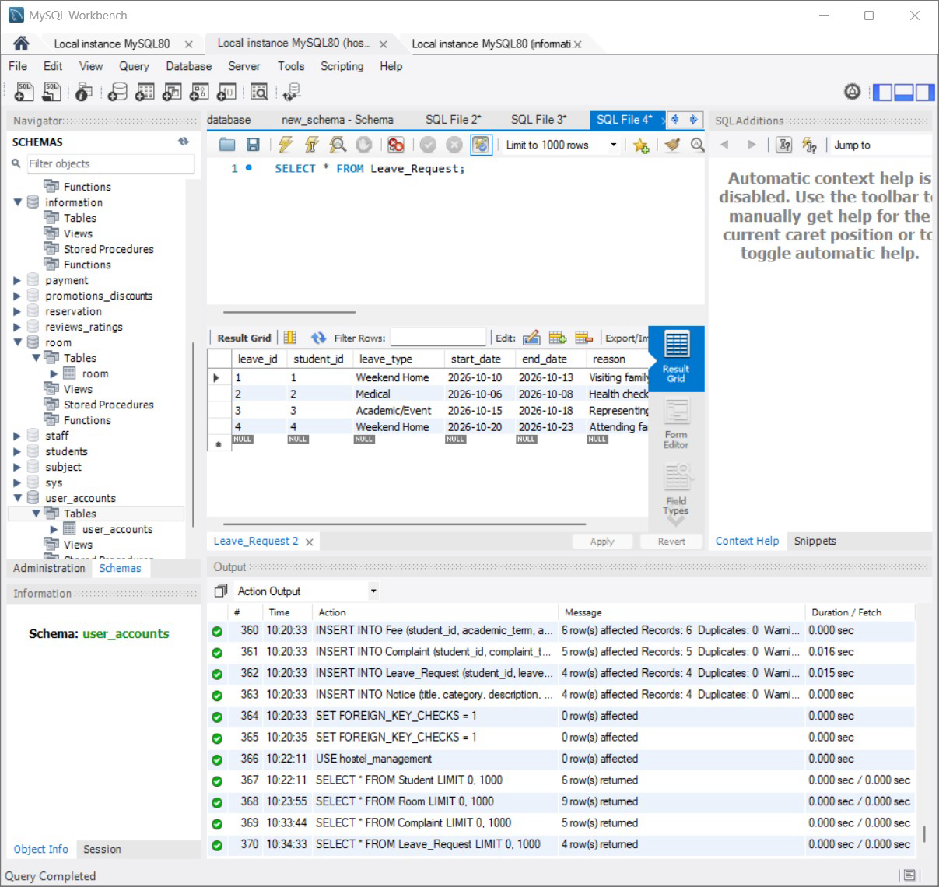
Figure 6. MySQL leave result: four requests in this snapshot.

10.6 Outstanding fee join
SELECT s.name, f.amount, f.amount_paid, f.due_amount
FROM Student s JOIN Fee f ON s.student_id = f.student_id
WHERE f.due_amount > 0 ORDER BY s.student_id;

name | amount | amount_paid | due_amount
Ananya Deshmukh | 45000.0 | 25000.0 | 20000.0
Riya Sen | 60000.0 | 30000.0 | 30000.0
Pooja Verma | 45000.0 | 0.0 | 45000.0
Output reproduced from the bundled SQLite snapshot; query syntax is also compatible with MySQL.
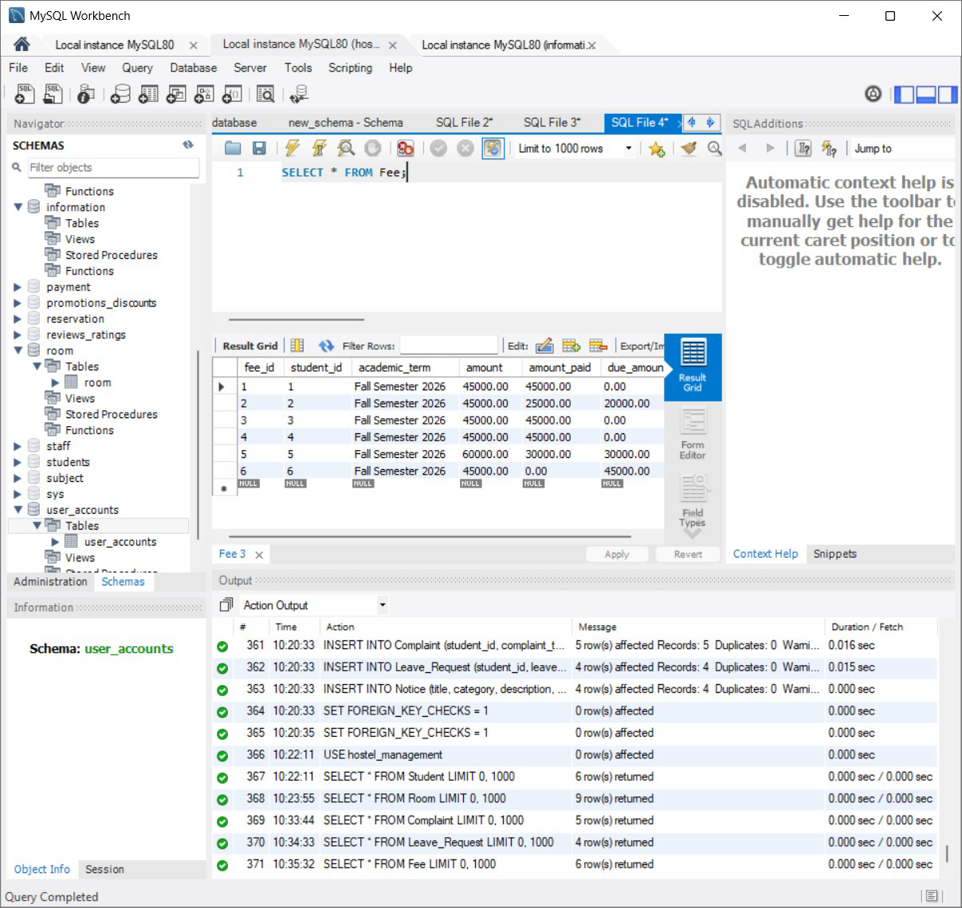
Figure 7. MySQL fee records: original seed state.

10.7 Aggregate fee totals
SELECT COUNT(*) AS records, SUM(amount) AS billed, SUM(amount_paid) AS paid, SUM(due_amount) AS due FROM Fee;

records | billed | paid | due
6 | 285000.0 | 190000.0 | 95000.0
Output reproduced from the bundled SQLite snapshot; query syntax is also compatible with MySQL.
The fee aggregate is ₹2,85,000 billed, ₹1,90,000 paid and ₹95,000 due in the bundled snapshot. SUM combines the amounts and COUNT returns the number of fee rows. These figures describe this dataset, rather than verified university collections.

10.8 Complaint grouping
SELECT status, COUNT(*) AS total FROM Complaint GROUP BY status ORDER BY status;

status | total
In Progress | 2
Pending | 2
Resolved | 1
Output reproduced from the bundled SQLite snapshot; query syntax is also compatible with MySQL.

10.9 Views
SELECT * FROM View_Student_Allocations;
SELECT * FROM View_Room_Occupancy;

The MySQL SQL file defines both views. View_Student_Allocations uses LEFT JOINs so students remain visible without an active allocation. View_Room_Occupancy joins rooms to hostels and computes available_beds. These views are not present in the bundled SQLite snapshot; their execution output still needs to be captured in MySQL.

11. UI Design and Screenshots

11.1 Student dashboard
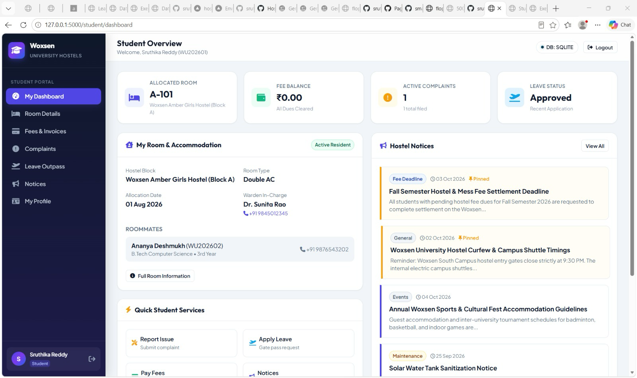
Figure 8. Supplied Student Overview dashboard, using SQLite.
The student dashboard places four immediate concerns at the top: room allocation, fee balance, active complaints and recent leave status. In the supplied screen, Sruthika Reddy is allocated A-101, has a ₹0 balance, one active complaint and an approved leave request. The accommodation card identifies the hostel, room type, allocation date, warden and roommate. Notices and quick service links appear beside and below it.
The left navigation connects to Room Details, Fees & Invoices, Complaints, Leave Outpass, Notices and My Profile. This gives the student a consistent way to move from an overview to a particular task. The “DB: SQLITE” badge is useful evidence of the engine serving this screen.

11.2 Warden dashboard
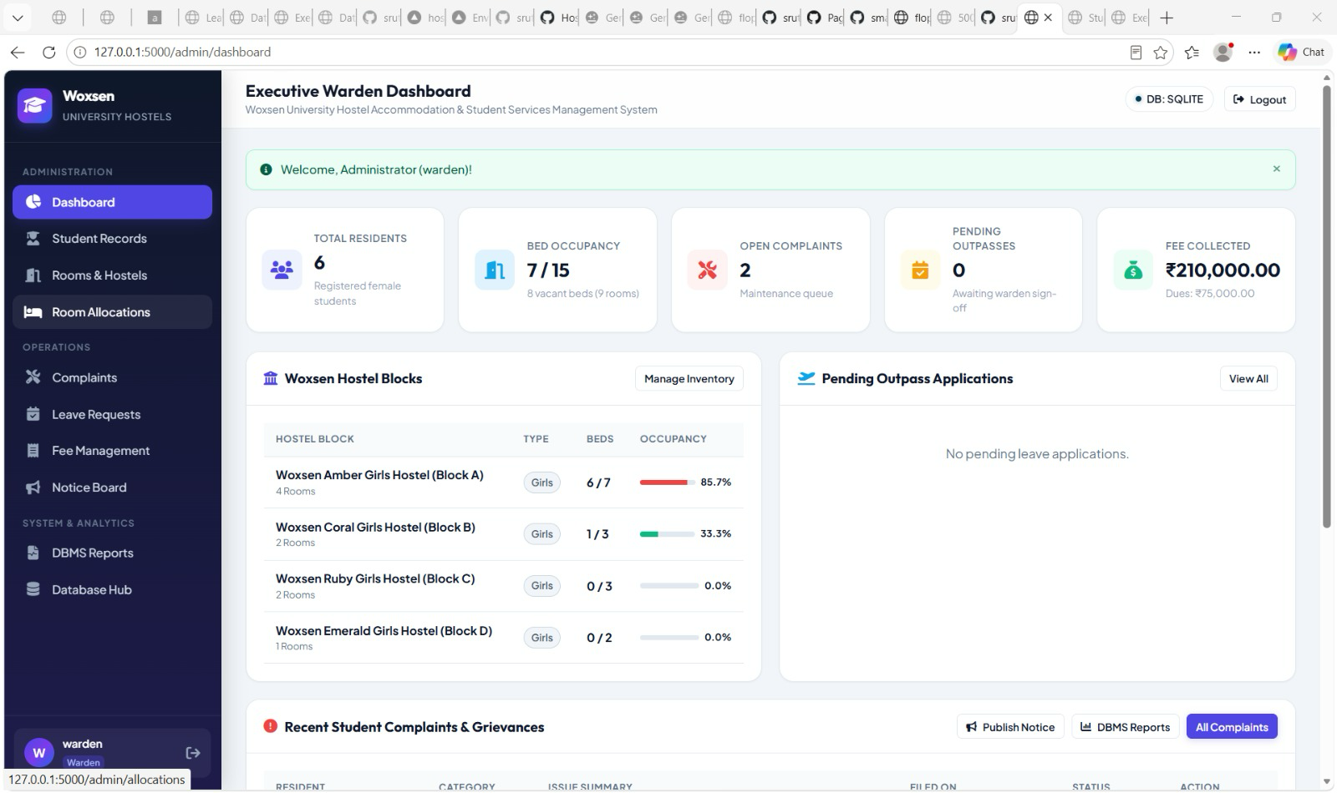
Figure 9. Supplied Executive Warden Dashboard, using SQLite.
The warden dashboard summarises six residents, seven occupied beds out of fifteen, two open complaints, zero pending outpasses and ₹2,10,000 collected with ₹75,000 due. Hostel cards show occupancy by block. The sidebar groups record management, operational services and reports, allowing a warden to move from a summary to a detailed list.
The code counts only Complaint.status = Pending for the dashboard’s complaint tile. Its “open complaints” wording therefore excludes In Progress tickets. The report retains the observed label while recognising this narrower calculation.

11.3 Comparing database states
Measure | Original MySQL image / bundled database | Later warden screen
Collected fees | ₹1,90,000 | ₹2,10,000
Outstanding fees | ₹95,000 | ₹75,000
Total billed | ₹2,85,000 | ₹2,85,000 (collected + due)
Pending leave requests | 2 in bundled data | 0
Stored occupied beds | 7 | 7
The screenshots are consistent with a later state, but no before/after operation log explains the changes. We therefore do not claim which payments or approval actions produced them. The seven occupied beds also cannot be treated as seven allocated residents: the bundled database has six active allocation rows.
Both dashboards demonstrate rendered overview pages. CRUD is currently a conceptual part of the project rather than an integrated application feature. A complete create, read, update and delete workflow remains future work; the supplied dashboards and database queries should not be presented as proof of full CRUD integration.

12. Implementation Details

12.1 Application architecture and connectivity
Requests pass from a browser to Flask routes, then to a shared Database class and the active relational engine. Flask renders Jinja templates using the retrieved data. api/app.py and api/index.py are deployment entry points that import the main application, configure template/static locations and export a WSGI handler; they are not independent implementations of the hostel business logic.
db.py provides fetch_one, fetch_all and execute_query helpers. MySQL connections use PyMySQL DictCursor; SQLite connections use sqlite3.Row and enable foreign keys. The wrapper converts %s placeholders to ? for SQLite. Each helper closes its connection after execution, and writes are committed through MySQL autocommit or an explicit SQLite commit.
The short excerpts below are taken from the reviewed source, with surrounding code omitted for readability.
def _normalize_sql(self, query: str) -> str:
if self.engine == 'sqlite':
return query.replace('%s', '?')
return query

Flask’s database tutorial provides context for connection lifecycle handling. It uses SQLite, while this project adds its own wrapper for both engines. The report uses that documentation for explanation rather than claiming that its example is the project’s code.

12.2 Complaint submission and follow-up
db.execute_query('''
INSERT INTO Complaint
(student_id, complaint_type, title, description, priority, status)
VALUES (%s, %s, %s, %s, %s, 'Pending')
''', (student_id, complaint_type, title, description, priority))

The repository contains a student complaint route that takes the student ID from the session and requires a category, title and description, along with a management route for status and resolution updates. These excerpts show the intended backend approach. The submission–review–status-update sequence in the presentation is a proposed workflow, not evidence of an integrated CRUD lifecycle.

12.3 Allocation logic
The repository allocation route includes checks for an existing active allocation and stored room capacity. It also contains calls to update occupancy after allocation, vacating and transfer. These describe the intended backend logic; full CRUD integration is pending. The checks and writes use separate helper connections, so a completed implementation would also need atomic transaction handling for concurrent requests.

12.4 Authentication and authorization
Werkzeug password-hash functions are used for registration/login, and Flask sessions identify the current user. student_required limits student routes to student accounts; admin_required permits both admin and warden roles. Seed/demo login conveniences are suitable for coursework, but should not be taken as a production security assessment.

12.5 Database compatibility and validation limits
MySQL defines due_amount as a generated column, while SQLite stores it directly. The payment routes and some fee INSERT statements explicitly write due_amount. Those statements fit the SQLite definition but need adjustment for MySQL: the MySQL path should omit the generated column and let the database calculate it. Placeholder conversion alone does not resolve this schema difference.
The leave route checks that dates and a reason are present, but the reviewed route does not reject an end date before a start date. The SQL definition also has no date-order CHECK. Database initialization suppresses individual MySQL statement errors, which can conceal a partial setup. These observations belong in the evaluation because they affect what the prototype can reliably demonstrate.

13. Testing
Verification for this report consisted of read-only SQL checks on the bundled database, review of the source routes and comparison with supplied screenshots. It did not include running the UI write flows or a live MySQL application test. Results below use that distinction.
Check | Result | Interpretation
Nine application tables | Verified in SQLite snapshot | Users, Hostel, Room, Student, Room_Allocation, Fee, Complaint, Leave_Request, Notice.
Row counts | 8, 4, 9, 6, 6, 6, 5, 4, 4 respectively | Hostel, Leave_Request and Notice fall below five.
Foreign-key integrity | PRAGMA foreign_key_check returned no rows | No orphan relationship reported in bundled SQLite data.
Fee arithmetic | Six balances match amount − amount_paid | Snapshot total due ₹95,000.
Active allocations | 6 rows | Stored occupancy totals 7.
Occupancy consistency | A-104 occupied = 1; active allocations = 0 | Seed mismatch requires reconciliation.
Student/warden overview | Observed in screenshots | Both display SQLite.
Complaint insert/update | Present in source | Source code exists; CRUD integration pending.
Student/notice deletion | Present in source | CRUD integration pending; no completed delete workflow claimed.
MySQL payment compatibility | Generated-column conflict found in source | Requires engine-aware fee statements.
Leave date order | No route/schema check identified | Invalid date order test still needed.
Concurrent allocations | Separate check/write connections | Atomic transaction test and design needed.
The seed row counts are not all compliant with the course minimum. A fifth hostel, leave request and notice should be added as meaningful demo records, rather than silently reporting an unmet requirement as passed. Any such additions should be reflected in the final SQL and screenshots.
The next implementation stage is to integrate CRUD into the interface and database, then verify it in MySQL mode. Testing should include temporary record creation and deletion, retrieval and updates, with before/after UI and database evidence. Duplicate identifiers, invalid foreign keys, full rooms, fee updates and invalid leave dates should also be checked. These are future tasks, not completed results.

14. Conclusion and Future Enhancements
This project helped us connect database concepts to a problem with several related workflows. The main strength is the separation of student, accommodation and service records: a complaint can be tracked without repeating a student’s profile, and an allocation can change without rewriting the room itself. The student and warden dashboards then present different views of those relationships.
The prototype also shows why a working overview screen is only part of database correctness. CRUD remains a concept to be integrated, while stored occupancy, generated balances and engine-specific definitions need to agree with the underlying records. The review identified further work: reconcile A-104’s occupancy, complete the seed counts, adjust MySQL fee statements and validate leave dates. These findings define the next stage of development.
Future work starts with integrating and testing CRUD across the application. Further improvements could calculate occupancy from active allocations, introduce transaction-safe room assignment, separate payment history from cumulative fee totals, enforce clearer administrator/warden permissions, and provide audit logs and automated notifications. A real deployment would also need a durable hosted database, tested backups and a retention policy.

15. References
Footnotes cite the supplied course handout, final presentation, screenshots, inspected repository and official documentation. No separate reference list appears in the supplied presentation. The documentation entries were added to support the technical explanations.
[1] Woxsen University. Instructions for Final Presentation: DBMS Course Project—AIML Wolves, CSE Tigers, CSE Rhinos. October 2026, pp. 1–2. Supplied handout.
[2] Sruthika, Thrishith and Sahasraa. A Database Management System for Hostel & Student Services. Final presentation, 12 slides, October 2026. Supplied PDF.
[3] Project group. MySQL Workbench results and student/warden dashboard screenshots. Eight supplied images, October 2026.
[4] Sruthika04. Hostel_Database-automation-. GitHub repository, commit c12a89c5d5004c10591677b8c063a07753a3c2cb, inspected 6 October 2026. https://github.com/sruthika04/Hostel_Database-automation- . Files reviewed: backend/database.sql, backend/db.py, backend/app.py, config.py, requirements.txt, api/app.py and api/index.py.
[5] Oracle. MySQL 8.0 Reference Manual, CREATE TABLE Statement. https://dev.mysql.com/doc/refman/8.0/en/create-table.html (accessed 6 October 2026).
[6] Oracle. MySQL 8.0 Reference Manual, FOREIGN KEY Constraints. https://dev.mysql.com/doc/refman/8.0/en/create-table-foreign-keys.html (accessed 6 October 2026).
[7] Oracle. MySQL 8.0 Reference Manual, Aggregate Function Descriptions. https://dev.mysql.com/doc/refman/8.0/en/aggregate-functions.html (accessed 6 October 2026).
[8] Pallets Projects. Flask Documentation, Define and Access the Database. https://flask.palletsprojects.com/en/stable/tutorial/database/ (accessed 6 October 2026).

16. Contribution of Each Member
The project responsibilities were divided between database development, backend development, and problem definition with frontend development. The presentation was organised into three consecutive sections so that the explanation moved from the problem to the technical design and then to the application workflow.

Sruthika — Database Development | Slides 9–12
Sruthika was responsible for the database component of the project. This work covered the hostel_management schema, the nine related tables, primary and foreign keys, and the sample records used to demonstrate student accommodation and services. Her contribution provided the data structure needed by the backend and the dashboards, including room allocations, fee balances, complaints, leave requests and notices. The database work also supported the SQL queries, joins and summaries discussed in this report.
Sruthika presented slides 9–12: Student Portal, Warden / Admin Portal, CRUD Operations, and System Workflow & Live Demo. She explained the two portal views and CRUD as the concept of creating, reading, updating and deleting records. CRUD was included for conceptual understanding and has not been integrated into the application. The complaint lifecycle illustrated the intended flow from submission to review and a status update; it should be understood as a proposed workflow rather than a completed end-to-end implementation.

Sahasraa — Backend Development | Slides 5–8
Sahasraa was responsible for backend development, including the Python–Flask structure, request handling, database access, session-based login and role checks. The backend contribution established the approach for connecting the interface to stored records. The repository includes code intended for service operations such as complaints, leave, allocations and fees.
Sahasraa presented slides 5–8: Proposed System, System Architecture, Database Design, and Entity Relationships & DBMS Concepts. She explained the responsibilities of students, wardens and administrators, followed by the frontend–backend–database structure. Her presentation then connected the nine-table design to primary keys, foreign keys, cardinality, referential integrity and CRUD operations. Presenting the database design explained how the backend uses the schema; it did not change the group’s division of implementation responsibilities.

Thrishith — Problem Statement and Frontend Development | Slides 1–4
Thrishith was responsible for defining the problem and developing the frontend. The problem statement identified the difficulties of managing hostel records across registers, spreadsheets and messages, then translated them into the project’s objectives. His frontend contribution focused on the HTML, CSS and JavaScript interface through which users access their records and services. This included the organisation of navigation, dashboard information and forms for the student and management workflows.
Thrishith presented slides 1–4: Project Title, Introduction, Problem Statement, and Objectives. He introduced the project and its intended users, explained the limitations of the manual approach, and established the six objectives: centralising student records, managing rooms and beds, tracking fees and dues, resolving complaints, handling leave requests and publishing notices. This opening section provided the context for the technical design and demonstration presented by the other members.
The three components depended on one another: the database defined the records and relationships, the backend implemented the operations on those records, and the frontend made those operations accessible to users. Each member therefore presented a connected part of the system while retaining a clear primary responsibility.

17. Appendix: GitHub Repository Link
Repository: https://github.com/sruthika04/Hostel_Database-automation-
API folder supplied by the group: https://github.com/sruthika04/Hostel_Database-automation-/tree/main/api
Reviewed commit: c12a89c5d5004c10591677b8c063a07753a3c2cb. The review used backend/database.sql, backend/db.py and backend/app.py for the schema and business logic, along with the API entry points, configuration, dependencies and bundled database.
The repository currently uses Hostel_Database-automation- as its name. The course handout requests DBMS-Course-Project and Presentation / Project-Report folders. Align the submission structure with the faculty’s instructions and upload the final report as PDF by 10 October 2026. The Word document is retained as the editable version.
Remaining work: faculty name; CRUD integration; before/after evidence and test results after integration; MySQL compatibility corrections and verification.

Sruthika, Thrishith and Sahasraa. A Database Management System for Hostel & Student Services. Final presentation, 12 slides, October 2026. Supplied PDF.
Sruthika, Thrishith and Sahasraa. A Database Management System for Hostel & Student Services. Final presentation, 12 slides, October 2026. Supplied PDF.
Woxsen University. Instructions for Final Presentation: DBMS Course Project—AIML Wolves, CSE Tigers, CSE Rhinos. October 2026, pp. 1–2. Supplied handout.
Sruthika04. Hostel_Database-automation-. GitHub repository, commit c12a89c5d5004c10591677b8c063a07753a3c2cb, inspected 6 October 2026. https://github.com/sruthika04/Hostel_Database-automation- . Files reviewed: backend/database.sql, backend/db.py, backend/app.py, config.py, requirements.txt, api/app.py and api/index.py.
Oracle. MySQL 8.0 Reference Manual, FOREIGN KEY Constraints. https://dev.mysql.com/doc/refman/8.0/en/create-table-foreign-keys.html (accessed 6 October 2026).
Oracle. MySQL 8.0 Reference Manual, CREATE TABLE Statement. https://dev.mysql.com/doc/refman/8.0/en/create-table.html (accessed 6 October 2026).
Oracle. MySQL 8.0 Reference Manual, Aggregate Function Descriptions. https://dev.mysql.com/doc/refman/8.0/en/aggregate-functions.html (accessed 6 October 2026).
Sruthika04. Hostel_Database-automation-. GitHub repository, commit c12a89c5d5004c10591677b8c063a07753a3c2cb, inspected 6 October 2026. https://github.com/sruthika04/Hostel_Database-automation- . Files reviewed: backend/database.sql, backend/db.py, backend/app.py, config.py, requirements.txt, api/app.py and api/index.py.
Pallets Projects. Flask Documentation, Define and Access the Database. https://flask.palletsprojects.com/en/stable/tutorial/database/ (accessed 6 October 2026).

